Borehole No. Exploration Borehole No 1
Location Samanhyia, Afram Plains
Latitude N 06°59.991’
Longitude W00°09.868’
Date started 28/04/2001
Date completed 29/04/2001

Summary Lithological Log
Depth(m)
From To

0 2 Soil/very weathered conglomerate

2 8.1 Very weathered conglomerate with clay
8.1 15.2 Weathered gravely conglomerate

15.2 21.3 Weathered medium to coarse grained sandstones, some gravel
21.3 24.4 Weathered coarse-grained sandstone and gravel
24.4 28.5 Weathered medium grained sandstone
28.5 46.7 Weathered medium to fine grained sandstone, some gravel
46.7 49.8 Weathered shaley fine-grained sandstone
49.8 52.8 Weathered medium to fine grained sandstone
52.8 53.9 Silty mudstone
53.9 58.9 Fairly weathered medium to fine grained sandstone
58.9 90.4 Medium to fine grained sandstone with odd gravel and pebble bands
90.4 96.2 Medium to fine grained sandstone
96.2 105.7 Medium to fine grained sandstones with coarse grained sandstone and
gravel
105.7 112.8 Medium to fine grained sandstone with some gravels
112.8 117.9 Medium to fine grained sandstone
117.9 121.9 Medium to fine grained sandstone with quartz veining

Comments on Water Production Zones
First water struck with small amount (42 l/min) at base of weathered gravel at 24m
Additional water produced from fairly weathered sandstone at base of weathered zone between 54-62m (flow increased incrementally from 75 to 240 l/min across this zone)
Additional small inflows from gravels at 82-86m and 97-99m maintained flow at 240 l/min
Well-defined fracture zone between 118-121m produced a substantial inflow of water (flow increased to 400 l/min)
Smearing of the borehole wall by fine grained sands within the weathered zone and clays produced by the drilling of shales from 49-49m reduced water inflow.
The water inflow zones at 24m, 54-62m 82-86m and 97-99m would need to be jetted with air prior to well construction. There was little evidence of fracturing except between 118-121m. Water inflow above that level seems to occur from weathered zones and coarser layers at depth.

Photo Lithological Log
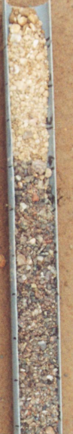
0-1 Very weathered conglomerate, grey quartzose pebbles weathered red,
ferruginous yellow, with brown orange silty fine sand matrix

1-2 Fragments of polymict conglomerate, mainly grey, white and pink with some yellow and brown mainly quartzose clasts. Sandy matrix, clayey in parts

2-3.1 Very weathered conglomerate, smaller clasts, mainly quartz,with orange pink and white sandy, silty clay matrix

3.1-4.1 Very weathered conglomerate with quartzose and feldspathic clast fragments. Some light brown to white silty clay matrix

4.1-5.1 Weathered conglomerate with mainly dark red, green bright orange and grey quartzose clasts. Some fragments of medium to coarse hard sandstone

5.1-6.1 About 50%fragments of quartzose clasts and 50% interbedded platey red brown fairly soft to fairly hard medium sandstone

6.1-7.1 Mainly green and red clast fragments, the green and white/green are silcrete or silcretised pebbles. Some red brown fragments of very hard silcretised medium sandstone, also some white quartz fragments

7.1-8.1 Very weathered rounded gravel with brown black sandy matrix, most gravels are orange brown, black or white silcretised sediments or quartz
8.1-9.1 Gravel of black, red, orange and white mainly quartz fragments with some red brown medium grained sandstone

9.1-10.2 Orange red and white coarse sand and gravel composed of white and black quartz and orange red medium to coarse grained fairly hard sandstone with some greenish yellow chloritic fragments

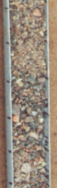
10.2-11.2 Mainly orange red, dark grey and white quartzitic fragments. Red brown rounded gravels, grey fine grained hard sandstones and red white and grey quartzitic fragments, some greenish yellow chloritic fragments

11.2-12.2 Orange and dark grey fragments some white, orange and white mainly quartz – crystalline, grey fine grained hard sandstone, some greenish
yellow chloritic fragments
12.2-13.2 Grey white and orange gravel, orange and white fragments of crystalline quartz, grey fragments of hard silcretised fine to medium sandstone, with odd greenish yellow chloritc fragment

13.2-14.2 Mainly orange grey and some white rounded to subrounded small pebbles to coarse gravel mainly of quartz, some greenish yellow fragments
14.2-15.2 Mainly orange grey and some white quartz and purple brown sandstone rounded to subrounded small pebbles to coarse gravel, some siliceous fine grained sandstone and odd greenish yellow fragments
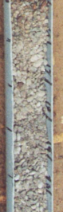
15.2-16.3 40% fragments of orange grey and white quartz gravel, 60% fragments light grey and orange medium to coarse sandstone

16.3-17.3 Light grey and orange fairly soft medium to coarse grained sandstone with some greenish yellow chloritic fragments

17.3-18.3 Light grey and orange soft medium sandstone

18.3-19.3 Light grey and orange very soft medium to coarse sandstone

19.3-20.3 Light grey and orange soft coarse to medium sandstone some greenish yellow chloritic fragments, light grey silty matrix
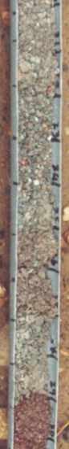
20.3-21.3 Light grey and orange soft medium sandstone with grey fine grained matrix

21.3-22.4 Light grey and orange coarse sandstone with gravel with fragments of yellow and white quartz, some grey clay

22.4-23.4 Light grey and orange coarse to medium sandstone and orange white and grey mainly quartzose gravel

23.4-24.4 White orange and grey quartzose coarse sand and gravel with hard orange light grey medium grained sandstone First water struck – 42 l/min

24.4-25.4 Light grey and orange soft medium to coarse sandstone, grains mainly white and orange quartz with light grey matrix

25.4-26.4 Orange grey fairly hard medium grained sandstone

26.4-27.4 Light grey to orange fairly soft medium grained sandstone, more orange than grey

27.4-28.5 Light grey and some orange soft medium to fine sandstone

28.5-29.5 Light grey and some orange soft medium to fine sandstone

29.5-30.5 10R3/2 dusky red fine to medium soft sandstone, some light blue grey mottles (Start of zone of borehole smearing causing reduced flow)

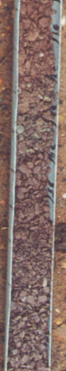
30.5-31.5 Dusky red fairly soft fine to medium sandstone

31.5-32.5 Dusky red fairly soft fine to medium sandstone

32.5-33.5 Dusky red fairly soft fine to medium sandstone with some thin grey bands

33.5-34.5 Dusky red fairly soft fine to medium sandstone, some thin grey bands and some white orange quartz gravel

34.5-35.6 Dusky red fairly soft to fairly hard platey fine to medium grained sandstone

35.6-36.6 Dusky red fairly soft fine to medium grained sandstone

36.6-37.6 Dusky red fairly soft fine to medium grained sandstone, larger fragments

37.6-38.6 Dusky red fairly soft fine to medium grained sandstone, with quartzose gravel fragments
38.6-39.6 Dusky red fairly soft to hard fine to medium grained sandstone

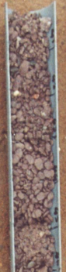
39.6-40.6 Dusky red fairly soft fine to medium grained sandstone with grey and brown fine grained quartzose gravels

40.6-41.7 Dusky red fairly hard medium to fine grained sandstone

417.-42.7 Dusky red fairly soft medium to fine grained sandstone

42.7-43.7 Dusky red fairly soft medium to fine grained sandstone with odd gravel fragment

43.7-44.7 Dusky red fairly soft medium to fine grained sandstone with light blue grey layer

44.7-45.7 Dusky red medium to coarse soft sandstone with fine sand matrix, some brown and white quartz gravels

45.7-46.7 Dusky red soft medium to fine sandstone with very hard shaley fine sandstone, some quartz gravel

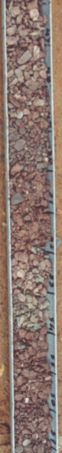
46.7-47.8 Hard dark brown shaley fine grained sandstone with bands of soft medium to fine grained sandstone and thin bands of light blue grey sandstone

47.8-48.8 Hard dark brown platey fine grained sandstone with softer shaley interbeds

48.8-49.8 Dark red brown hard silty fine grained sand, platey fragments, with soft interbedded clayey silty mudstones

49.8-50.8 Dusky red medium to coarse grained soft sandstone, some gravel

50.8-51.8 Dusky red soft medium to fine grained sandstone

51.8-52.8 Dusky red soft silty fine to medium grained sandstone

52.8-53.9 Mottled dark red brown and light grey silty mudstones

53.9-54.9 Dark red brown medium to fine soft sandstones above very hard light grey orange medium to fine grained sandstone (Flow – 52 l/min)

54.9-55.9 Soft dark red brown medium to fine grained sandstone and silty fine grained sandstone with odd light grey mottles

55.9-56.9 Dark red brown fairly soft medium to fine sandstone

56.9-57.9 Dark red brown fairly soft to fairly hard medium to fine grained sandstone
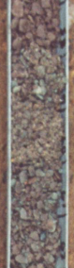

57.9-58.9 Dark brown fairly soft platey friable medium to fine grained sandstone

58.9-59.9 Mottled dark red brown and blue grey fairly soft medium to fine grained sandstone

59.9-61 Mottled blue grey and dark red brown fairly soft to fairly hard medium to fine grained sandstone with some coarse sand grains
(Flow increased to 75 l/min)
61-62 Mottled red brown and blue grey fairly soft to fairly hard medium to fine grained sandstone
(Flow increased to 240 l/min)
62-63 Mottled red brown and blue grey fairly soft to fairly hard medium to fine grained sandstone

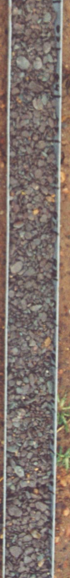
63-64 Mottled red brown and blue grey fairly soft to fairly hard medium to fine grained sandstone

64-65 Mottled red brown and blue grey fairly soft to fairly hard medium to fine grained sandstone

65-66 Mottled red brown and blue grey fairly soft to fairly hard medium to fine grained sandstone

66-67.1 Mottled red brown and blue grey fairly soft to fairly hard medium to fine grained sandstone

67.1-68.1 Mottled red brown and blue grey fairly soft to fairly hard medium to fine grained sandstone, with some yellow and grey rounded gravels

68.1-69.1 Mottled red brown and blue grey fairly soft medium to fine grained
sandstone

69.1-70.1 Mottled dark red brown and grey fairly soft to fairly hard medium to fine grained sandstone, some coarse sand granules

70.1-71.1 Mottled dark red brown and dark grey brown fairly soft medium to fine grained sandstone

71.1-72.2 Mottled dark red brown and dark blue grey fairly soft to fairly hard medium to fine grained sandstone

72.2-73.2 Mottled dark red brown and dark blue grey fairly soft to fairly hard medium to fine grained sandstone

73.2-74.2 Mottled dark red brown and dark blue grey fairly soft to fairly hard medium to fine grained sandstone with fragments of orange yellow quartzose pebbles
74.2-75.2 Mottled dark red brown and dark grey fairly soft to hard medium to fine grained sandstone, odd weathered orange pebble fragment

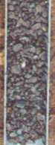
75.2-76.2 Mottled dark red brown and dark grey fairly soft medium to fine grained sandstone with some coarse sand granules and odd orange yellow and white quartz pebble fragment
76.2-77.2 Mottled mainly dark red brown and some bands of dark grey fairly soft to hard medium to fine grained sandstone

77.2-78.2 Mottled mainly dark red brown and some bands of dark grey fairly soft to hard medium to fine grained sandstone, with rounded yellow quartzose coarse gravels
78.2-79.3 Mottled mainly dark red brown and some bands of dark grey fairly soft to hard medium to fine grained sandstone, with rounded yellow quartzose coarse gravels
79.3-80.3 Mottled dark red brown and dark blue grey soft to hard silty medium to fine grained sandstone
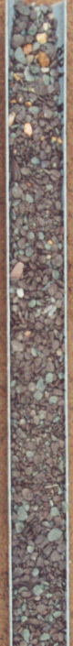
80.3-81.3 Mottled dark red brown fairly soft medium to fine grained sandstone with blue grey shaley siltstone to fine grained sandstone, odd reddened quartz gravel

81.3-82.3 Dark red brown and grey hard to fairly soft medium to fine grained sandstone, with yellow orange gravel (Small increase in flow)

82.3-83.3 Mottled dark brown and grey fairly soft medium to fine grained sandstone, odd yellow white rounded gravel

83.3-84.3 Mottled dark red brown and grey fairly hard to fairly soft medium to fine grained sandstone, some yellow gravel

84.3-85.3 Mottled dark red brown and grey fairly soft medium to fine grained sandstone

85.3-86.4 Mottled dark red brown and grey fairly soft medium to fine grained sandstone

86.4-87.4 Mainly dark red brown with some grey fairly soft to fairly hard medium to fine grained sandstone

87.4-88.4 Mottled dark red brown and grey fairly hard to fairly soft medium to fine grained sandstone

88.4-89.4 Mottled dark red brown and grey fairly hard to fairly soft medium to fine grained sandstone

89.4-90.4 Mottled dark red brown and grey fairly hard to fairly soft medium to fine grained sandstone

90.4-91.4 Dark red brown hard medium to fine grained sandstone some blue grey sandstone layers

91.4-92.5 Mottled dark red brown and blue grey fairly soft to fairly hard medium to fine grained sandstone

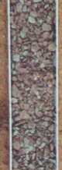
92.5-93.5 Mottled dark red brown and blue grey fairly soft to fairly hard medium to fine grained sandstone

93.5-94.5 Mottled dark red brown and some blue grey medium to fine grained fairly hard to soft sandstone

94.5-95.5 Mottled dark red brown and some blue grey medium to fine grained fairly hard to soft sandstone

95.5-96.5 Mottled dark red brown and some blue grey medium to fine grained fairly hard to soft sandstone

96.5-97.5 Mottled dark brown grey fairly soft to fairly hard medium to fine grained sandstone
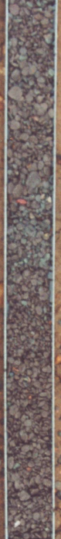
97.5-98.6 Dark brown medium to fine grained fairly soft friable sandstone, some coarse sand granules and grey mottles. Odd subrounded orange white quartz pebble fragments

98.6-99.6 Mottled dark red brown and grey fairly soft to fairly hard medium to fine grained sandstone, some coarse sand grains and red quartz gravel fragments (Small increase in flow?)
99.6-100.6 Mottled brown and grey fairly soft medium to fine grained sandstone some coarse sand grains

100.6-101.6 Mottled grey and dark red brown fairly soft to fairly hard medium to fine grained sandstone with some hard bands and coarse sand granules

101.6-102.6 Mottled dark red brown and grey fairly soft to fairly hard medium to fine grained sandstone, some patches of hard shale, some coarse sand granules and yellow brown gravel clasts

102.6-103.6 Dark red brown fairly soft to fairly hard medium to fine sandstone with grey patches, some coarse sand grains

103.6-104.7 Dark brown with orange grains and grey patches fairly soft to fairly hard medium to fine grained sandstone

104.7-105.7 Dark brown with orange grains and grey patches fairly soft to fairly hard medium to fine grained sandstone

105.7-106.7 Dark brown fairly soft medium to fine grained sandstone with few grey patches

106.7-107.7 Dark brown fairly soft medium to fine sandstone

107.7-108.7 Dark brown fairly soft medium to fine sandstone with some red to dark red quartzose rounded fine gravels

108.7-109.7 Dark brown fairly soft to fairly hard medium to fine grained sandstone, some yellow, grey and white quartz gravel fragments
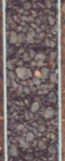

109.7-110.7 Dark brown fairly soft to fairly hard medium to fine grained sandstone, some grey black quartz gravel fragments

110.7-111.8 Dark brown medium to fine grained friable fairly hard sandstone

111.8-112.8 Dark brown medium to fine grained fairly soft to fairly hard sandstone

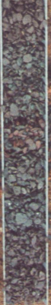
112.8-113.8 Mainly grey with some dark brown medium to fine grained fairly soft to fairly hard sandstone

113.8-114.8 Hard grey and some fairly soft dark red brown medium to fine grained sandstone

114.8-115.8 Grey and red brown fairly soft to hard medium to fine sandstone with some red brown shaley siltstone

115.8-116.8 Grey hard to fairly hard medium to fine grained sandstone, some coarse sand granules, mainly orange

116.8-117.9 Hard grey orange and fairly soft dark brown medium to fine grained sandstones, 80%grey and 20% brown - mottled

117.9-118.9 Hard dark brown and subordinate dark brownish grey medium to fine grained sandstone some white vein quartz (Flow increased – 400 l/min)

118.9-119.9 Very hard dark brown medium to fine grained sandstone with some fairly soft shaley layers, odd grey brown patches and white vein quartz
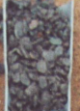
119.9-120.9 Mottled dark brown and brownish grey fairly hard to fairly soft medium to fine grained sandstone with some white vein quartz and odd green white quartz pebble fragment

120.9-121.9 Hard dark grey and orange medium to fine grained sandstone

